Assignment 1:

Create VM and setup SQL server and install SSMS:

1. Windows 2016 server is installed in VM Virtual Box

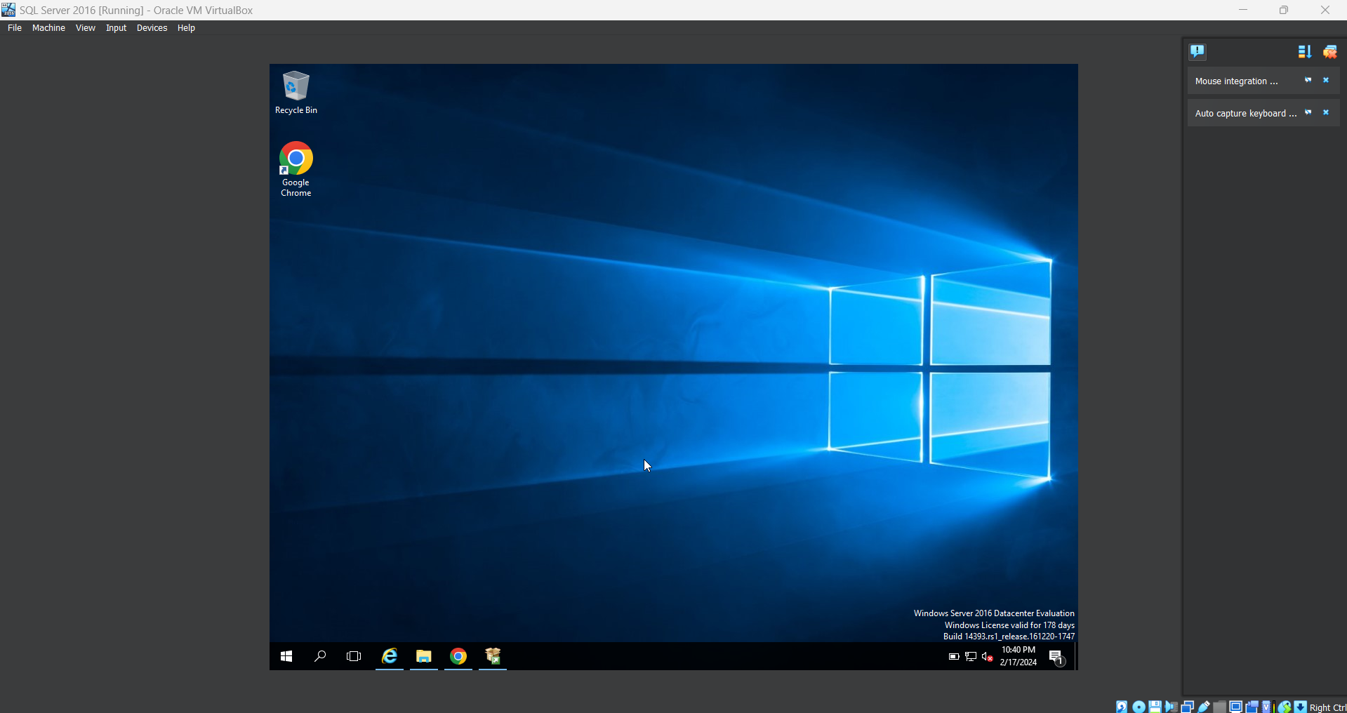

1. Download SQL server 2016 from Microsoft website and place it in any Drive,

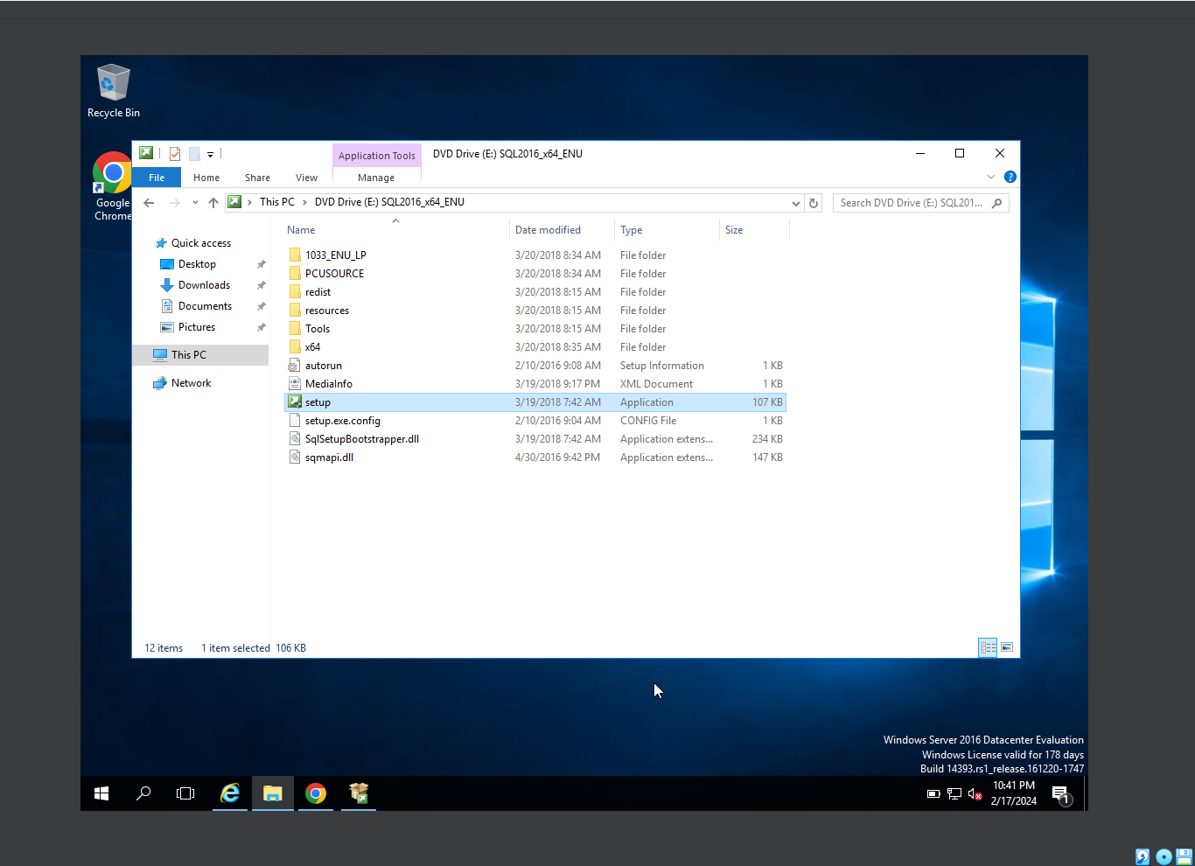

1. Open the setup file in admin mode, this will perform the SQL server installation. As hsown below snips

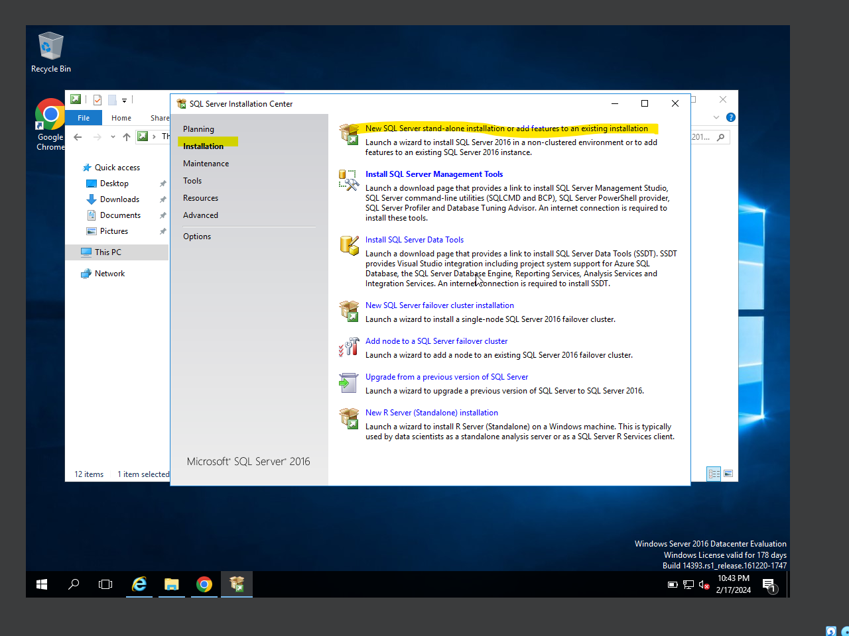

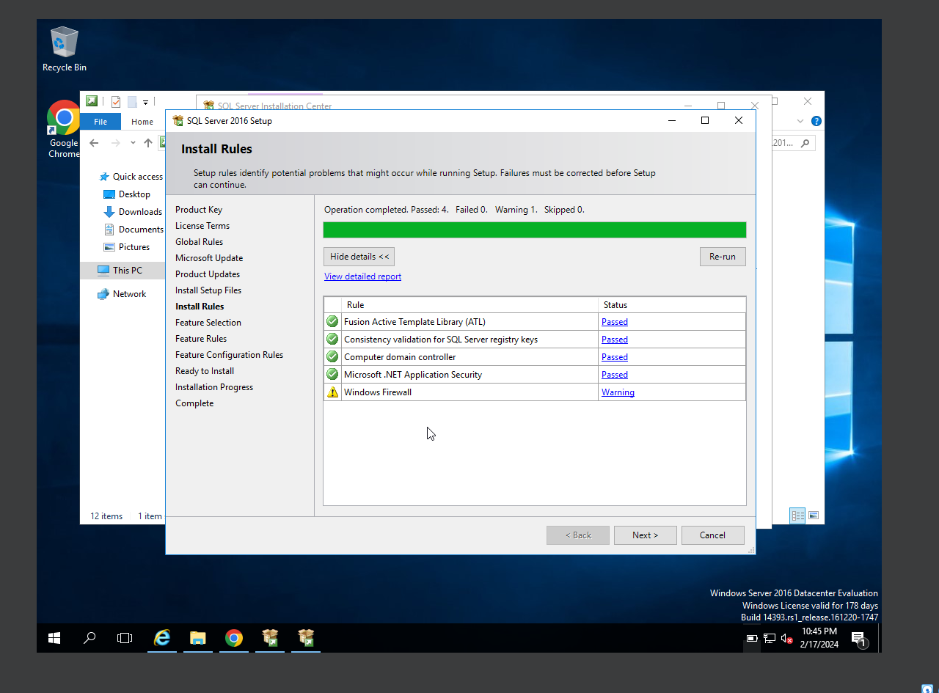

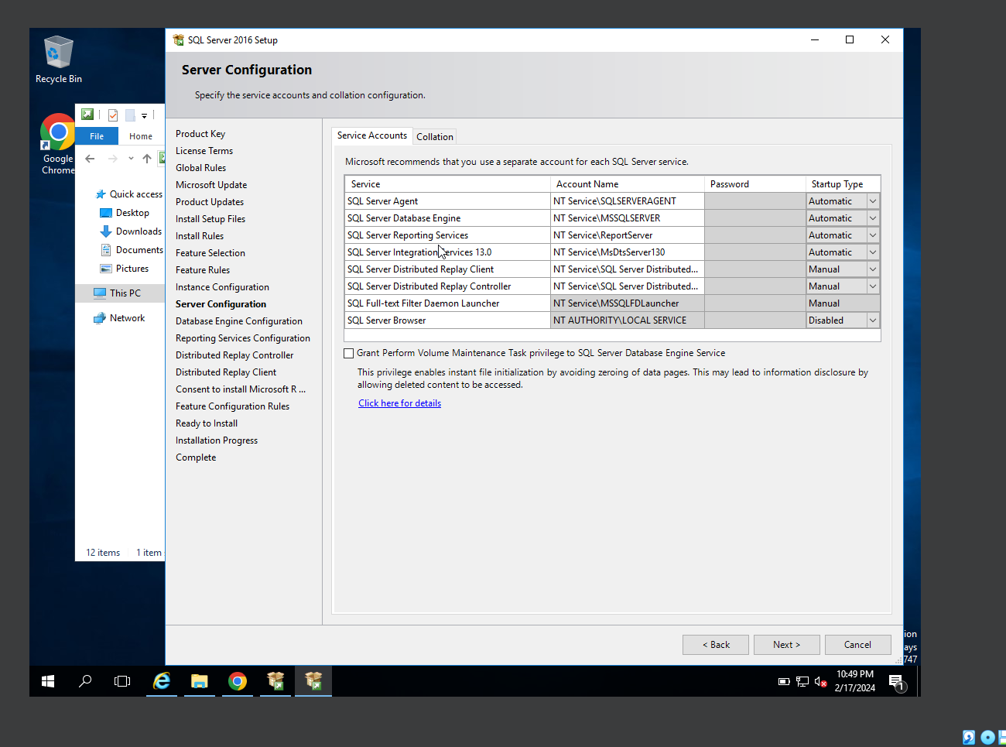

Installed SQL server, PFB snip. After this we need to restart the server.

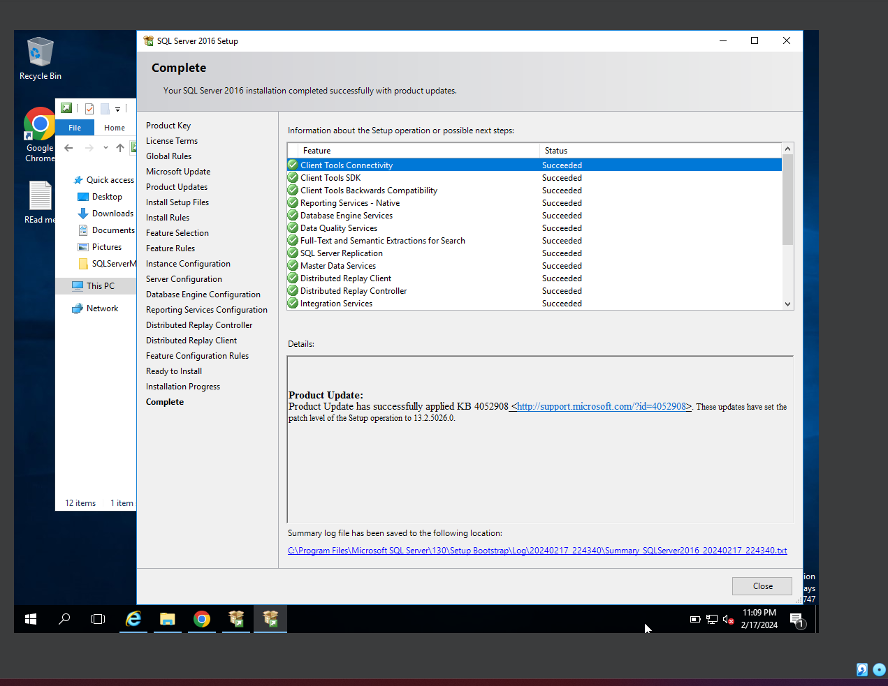

Post restart, SSMS also installed, PFB snip

